Software Specifications Document (SSD)
Entity Enhancement

Profile
Title | Flexible GL Chart of Accounts Changer
Tracking # | 129762
Product Line | Aria 27 , Aria 4
Module(s) | GL Module (will affect all Aria Database)
Entity Type (Screen/Report) | Screen/ Program
Entity(s) | GL Account Code Structure
Customer | Standard program
Date Created | 10/03/2005
Author | Angie Mohsen Eissa
Date Edited | 10/25/2005
Editor | Angie Eissa
Analysis | Approved By
Analysis | Approval Date | MM / DD / YYYY
Conceptual Design | Approved By
Conceptual Design | Approval Date | MM / DD / YYYY
Detailed Design | Approved By
Detailed Design | Approval Date | MM / DD / YYYY

Table of Contents
Profile 1
Table of Contents 2
Document Sections 3
Versions 3
Vision 4
Needs 4
CFN – Customer Functional Needs 4
AFN – Aria Functional Needs 4
ATC – Aria Technical Needs 4
ADT – Aria Documentation Needs 5
Project Scope 5
1. In/Out Domains 5
2. Assumptions 5
Entity Features 6
User Interface (UI) 6
Option Grid 8
UI Rules 9
Option Grid Rules 9
Database Design 14

Document Sections
Section | Included?
Analysis
Vision | Yes
Stakeholders | Yes
Needs *
Customer Functional Needs | Yes
Customer Technical Needs
Aria Functional Needs | Yes
Aria Technical Needs
Aria Testing Needs
Aria Marketing Needs
Aria Documentation Needs | Yes
Supplementary Needs
Project Scope | Yes
Conceptual Design | Yes
Entity Features | Yes
User Interface (UI) | Yes
Option Grid
Use Cases
Detailed Design | Yes
UI Rules | Yes
Option Grid Rules
Database Design | Yes
Testing Cases | Yes

Versions
Ver # | Date | Modified By | Sections Change Tracking
Ver # | Date | Modified By | New | Deleted | Changed
0.1 | 10/03/2005 | Angie Eissa | Writing the document from scratch.
0.2 | 10/25/2005 | Angie Eissa | - Added screens 5: Replace of existing segment values and  - Add an Aria Need (4): Manually checking previous and modified account codes requested by business architect and screen 6 was designed to satiscreen this need. .

Vision

When a company expands its businesses, such as adding more products, product lines, creating new entire divisions, adopting new projects; in this case they would need to change the existing GL chart of accounts structure to reflect the newly added units, sects or divisions. Changing the GL Chart of Accounts structure will affect predefined account segments, all the existing account number in all the GL files in addition to changing the structure we will need to update the existing data stored (account numbers) in all the tables – whether codes, master, transaction files - to accommodate with the newly modified GL Account structure.

This document will explain the new Aria GL enhanced feature that will enable the customer to flexibly change the existing chart of accounts after having already worked with an old structure, update the old structure in all the Aria Database tables, and begin applying the newly structure immediately after the conversion.

Needs

CFN – Customer Functional Needs
- Change the existing “GL account code structure” to reflect any changes in the business.
  - Add new segments to existing structure code structure.
  - Increase the number of digits in the existing segment(s).
- Apply new values to the added segment.
  - Add new value(s) to the added segment or increased digits.
  - Update this new value of the added account segment or increased segment digits in all GL tables and all aria files.
- The program should add the modified account code structure and values(s) to all GL transactions including history, new, posted, non-posted transactions.

AFN – Aria Functional Needs

- Need to enable the user to view how will the account look like after the structure change
  - To allow the user to manually update or change an account code
- Need to exclude this feature to certain staff level, senior level and with approval grants and/or security privileges.
- Need to save any changes done to the GL chart of account in a file/log and enable the user to view the previous and new account code structure.

ATC – Aria Technical Needs
- Need to develop this program in a way that is self-explanatory and easy to use.

ADT – Aria Documentation Needs
- Need to write a descriptive scenario for how and when to use the Flexible GL Chart of Accounts Changer and its impact on the existing accounts stored in the aria database.

Project Scope

In/Out Domains
- The program will affect the entire database as it will update all files that hold account numbers.
- The program will also affect system files that holding GL setup to adjust and change “account code structure” setup files.

Assumptions:
- The program will change the account numbers ONLY and will not change the account’s names and description since it is not possible to estimate the number of characters used for the description of each account. User will have to check and manually adjust the account descriptions to indicate the division.
- Current accounts on the GL link code will also be updated with this change and new division’s link code should be added manually.
- New segments, along with their related account numbers, will be added manually.
- The added segment must be the non-major segment as major segments are not inter-changeable.

Entity Features
- Account Structure Change
  - Add new segments to the existing code structure.
  - Increase an existing segments width (number of digits).
  - Add new values to the added segment. Or to the increased segments digits.
  - Replace a value or the list of values of an existing segment.
- Transaction monitoring and control
  - Keep track of history of changes to the GL Account code structure.
  - Audit Trail the user(s) actions when changing the GL Account code structure.
  - Keep a processing log viewable by the user with the ability to abort the transaction and rollback any changes at any point before committing the transaction (updating the structure and values in all the aria files)

User Interface (UI)
1. This screen will be accessible from the GL Module >> File Menu >>
Place ‘Flexible GL Account Code Structure Changer’ under General Ledger Setup item.

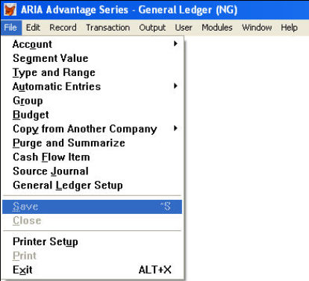
a. The first Tab-sheet of the screen

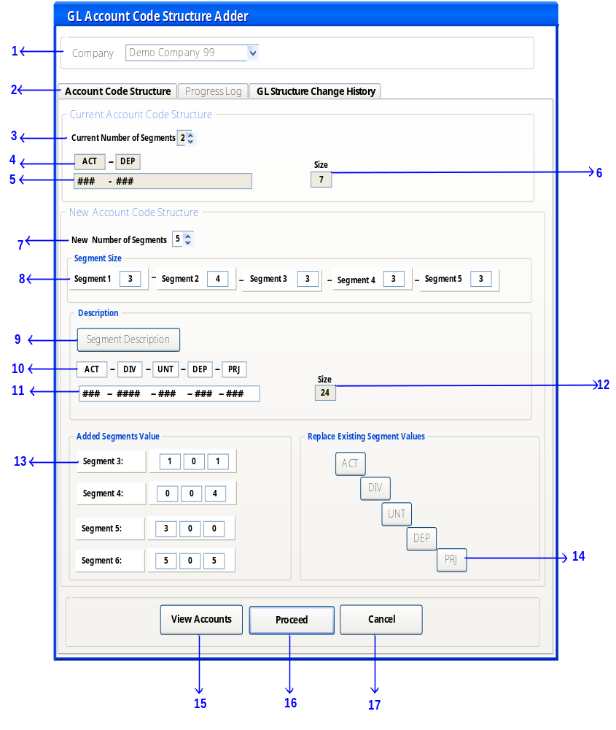

UI Rules
Ser. | Attribute | Value
1 | Description | Select a company to apply the GL account code structure.
 | Control Type | Combo box
 | Caption | Company
 | Visible | True
 | Enabled | True
 | Mandatory | True
 | Tab Sequence | 1
 | Default Value | Default company
 | List of Values (LOV) | Select  From SYCCOMP
 | On Select | Show the code structure for the selected company.  Store the company ID in a variable in memory as ‘SelCom’
2 | Description | This screen consists of three tab-pages:  The first tab-sheet is where the user will view the existing GL Account code structure and may add new segments to his/her existing account code structure. The second tab-sheet will be a processing log that will show each action taken by the system in order to update Aria with the new structure.  The third tab-sheet will display all the changes that have taken place on the account code structures for all companies. Each tab-sheet will be described in detail below
 | Control Type | Tabs
 | Caption | Tab1: Account code structure  Tab2: Processing Log  Tab3: GL change History
 | Visible | True
 | Enabled | True
 | Tab –sheet order | Tab1: Account code structure (tab order 1)  Tab2: Processing Log (tab order 2)  Tab3: GL change History (tab order 3)
 | Default Value | The default view of this screen is the first tab-sheet.
 | On Select | Open the selected tab page
3 | Description | We will display for the user the current account structure. In here we will display to the user the current number of segments in the account code structure.
 | Control Type | Edit box
 | Source | Select NACSNOSEG  From ACCOD  For the value stored in SelCom.
 | Caption | Current number of segments
 | Visible | True
 | Enabled | False
4 | Description | For each account segment we will add an edit box
 | Control Type | Edit box
 | Source | For all the records in ACCOD.CACSHDES  For the selected company SelCom.
 | Caption | No caption
 | Disabled | True
5 | Description | We will graphically display the current account code structure mask. Each digit is represented by a # sign and you will add a (--) hyphen between every two segments.
 | Control Type | Edit box
 | Source | Accod. cacsmask
 | Caption | No caption
 | Enabled | False
6 | Description | The size of the account code mask including separating hyphens.
 | Control Type | Edit Box
 | Source | ACCOD.NACSSEGSZ
 | Caption | Current Size
 | Enabled | False
7 | Description | The user may here modify the number of account segments by adding new segments the exiting structure.  Note that the user may not decrease the number of segments already used.
 | Control Type | Spinner
 | Destination | ACCOD.NACSNOSEG
 | Caption | ‘New number of segments’
 | Visible | True
 | Enabled | True
 | Tab Sequence | 1
 | Default Value | Current number of account segments + 1
 | List of Values (LOV) | Not less than existing no of segments + 1  AND not greater than 6
 | Validations | The range for the spinner must be between the existing number of accounts + 1AND not greater than 6.
 | On Selection | Display segment group controls in the segment size, segment description, and segment values.
6 | Description | Old Segment size
 | Control Type | Edit box
 | Source | Ncssegno  Nacssize
 | Caption | Group header: segment size  Each segment number you will show a disabled edit box showing the account segment size.
 | Visible | True
 | Enabled | True
 | Mandatory | False
 | Validations | Search for the Accod. Ncssegno and display the account size number from Accod. Nacssize
8 | Description | This control will be shown according to the number of new segments added by the user. In here we will specify the segment size for each newly added segments.
 | Control Type | Edit box
 | Caption | Segment number (must be incremental to follow the last segment number in the existing code structure.) i.e.: Existing account code structure consists of 2 segments then the newly visible group will be labeled ‘segment 3’ if the user had only added one segment and ‘segment 4’ if the user had added two new segment to the account code structure.
 | Visible | True
 | Enabled | True
 | Mandatory | True
 | Tab Sequence | 4
 | Validations | Validate that value entered for each segment width (V)  3 ≤ V ≥ 6
 | On Insert | Add each value entered by the user for newly added segments / values for already existing segment and after each segment add 1 for the hyphen separating between segment..  Validate that maximum permitted account segment size acssegssize is 24 digits including the hyphens.  In Example  Segment 1: 3 digits -- Segment 2: 3 digits  Then 3 + 1 (hyphen) + 3 = 7  If the total number of digits reaches its maximum limit 24 then do not allow at any point then disable the rest of the edits and show user message that account structure size can not be exceeded.
9 | Description | To allow users to enter description for added segments
 | Control Type | Command button
 | Caption | Segment description
 | Visible | True
 | Enabled | True
 | Mandatory | True
 | Tab Sequence | 5
 | On click/ on press | Open account code description screen 4 shown below
10 | Description | The system will show the short description entered by the user in the edit boxes
 | Control Type | Edit boxes
 | Save in | ACCOD.CACSSHDES
 | Caption | No caption
 | Visible | True
 | Enabled | True
 | Mandatory | True
 | Tab Sequence | 6
 | Validations | Only allow numeric values in these edits from 0 to 9
11 | Description | Account structure mask
 | Control Type | Edit boxes
 | Caption | No caption
 | Visible | True
 | Enabled | True
 | Mandatory | False
 | Tab Sequence | 7
12 | Description | Display the new account code structure size acssegssize
 | Control Type | Edit box
 | Save in | ACCOD.ACSSEGSZ
 | Caption | New Size
 | Visible | True
 | Enabled | True
 | Mandatory | False
13 | Description | For each added segment value the user must enter the values that will be update to all account numbers in all aria files.
 | Control Type | Edit boxes
 | Save in | GLSEGVAL.CSEGVAL
 | Caption | Group header : Added segment size  Each segment is labeled by its number.
 | Visible | True (show a control for each added segment)
 | Enabled | True
 | Mandatory | True
 | Tab Sequence | 8 (the segment value edit boxes tab sequence will be arranged by the segment number)
 | Validations | Numeric values only
14 | Description | This is another feature available through this screen which will enable the user to display the existing values for each segment and replace one or more of these values
 | Control Type | Command button for each segment
 | Caption | Caption for each button is the segment short description.
 | Visible | True
 | Enabled | True
 | Tab Sequence | 9
 | On Click/ On Press | Open screen ID: 5
15 | Description | This command will allow the user to view the previous and new account code structure before actual database update.
 | Control Type | Command button
 | Caption | View Accounts
 | Visible | True
 | Enabled | True
 | Tab Sequence | 10
 | On Click/ On Press | Open screen ID: 06
16 | Description | This command will trigger the update transaction of the changed GL structure.
 | Control Type | Command button
 | Caption | Proceed Now
 | Visible | True
 | Enabled | True
 | Tab Sequence | 11
 | On Click/ On Press | First will save all changes in the GLSTRCHG, GLSEGCHG, GLVALCHG tables  GL_Link, GLTYPES, GLSEGVAL, GLACCHAR, CODES, APSETUP, GLSETUP, APDIST, GLDIST, GLACBALS, GLTRANSDT, GLPTRNDT, GLBUDDT,GLGRPDT, GLTMPBAL, INVHDR, INVLINE, INVCHRG, STYINVJL, RETHDR, RETLINE, DEBIT, CREDIT, POSHDR, POSLINE, CUTTKHDR, CUTLINE, APINVTKT, APINVAHD, APINVHDR, APINVDT, APINVTKT, APCHECKS, APDIV, APRBALV, APVENDOR, APINVDT, ARHIST, CUTTKTH, GLAUTDT, MATINVJL, MINVCHRG, MINVHDR, MINVLINE  The program should also change the GL chart of accounts and add the values of newly added segments to all of account numbers in the files and add a hyphen “-” is to separate the Update the newly added values of the new segments to. The program should search ALL ARIA FILES and isolate the files that are holding GL account numbers. Then, the program should add the same (-001) to all GL account numbers in these files. This will also include all Aria modules installed at the customer’s.
16 | Description | Standard cancellation button which typically ignores all changes / entries done by the user and closes the screen.
 | Control Type | Command button
 | Caption | ‘Cancel’
 | Enabled | True
 | Tab Sequence | Requires exceptional user action
 | On Click/ On Press | Display user warning message ‘This will cause cancellation of all changes done to your current account code structure, are you sure you want to cancel?’ Yes will confirm cancellation ignoring all users actions in this screen and close the screen. No will take the user back to the same screen.

b. The second Tab-sheet of the screen

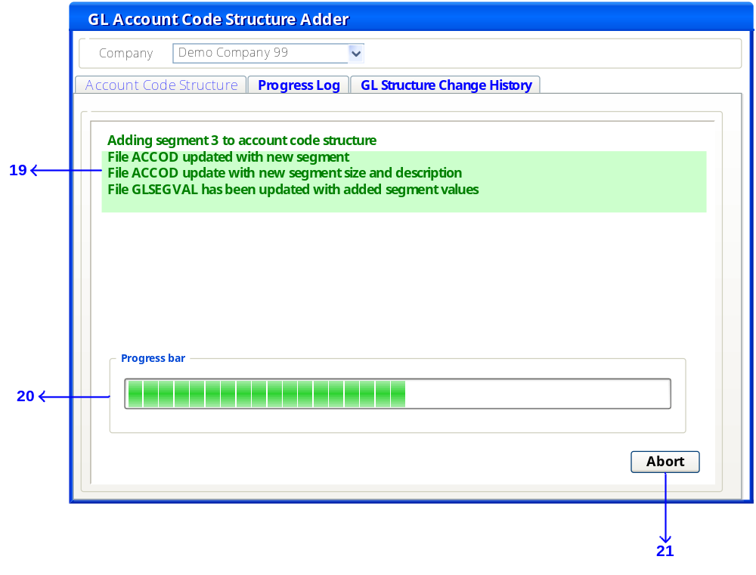
Ser. | Attribute | Value
19 | Description | A progress text will be printed in parallel to each step conducted in the file update transaction.
 | Control Type | Textual
 | Caption | The Transaction type
 | Visible | True
20 | Description | A thermometer to show graphically to the user the progress done with the files’ update.
 | Control Type | Progress bar
 | Caption | Progress bar
 | Enabled | True
 | Progress stations | - updating the GL module files  - updating Codes, GL link files  - updating master files  - updating module transaction files.
21 | Description | Ability to abort the GL Account structure change transaction and rollback any changes at any point before committing the transaction (updating the structure and values in all the aria files)
 | Control Type | Command button
 | Caption | Abort
 | Visible | True
 | Enabled | True
 | Mandatory | False
 | On Click/ On Press | Abort update transaction rolling back all changes  No database update will take place.  Database is restored to its original state before this transaction took place.  Delete the inserted record in GLSTRCHG, GLSEGCHG, GLVALCHG with the GLSRTCHGID where ChgCommitted=No

c. The third Tab-sheet of the screen: GL Account structure Change History

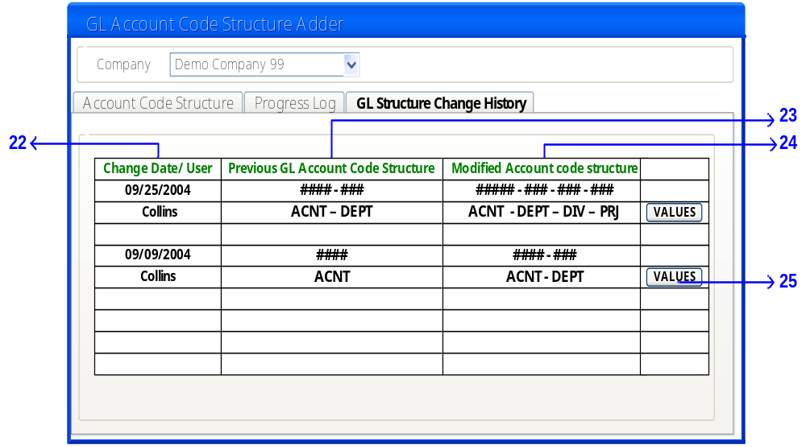

UI RULES
Ser. | Attribute | Value
22 | Description | The first column will list the date and user that changed the GL account structure
 | Control Type | Grid
 | Column header | Change Date/ User
 | Contents | C-add Date  C-add User
 | Enabled | False
23 | Description | Previous GL account code structure.
 | Control Type | Grid
 | Column header | Previous GL account code structure.
 | Contents | GLSTRCHG.PRVCACSMASK  GLSTRCHG.PRVCACSEGDES
 | Visible | True
 | Enabled | True
24 | Description | Modified account code structure
 | Control Type | Grid
 | Column header | Modified account code structure
 | Column contents | NWACSMASK  NWACSEGDESC
 | Visible | True
 | Enabled | True
 | Mandatory | False
25 | Description | The
 | Control Type | Command button
 | Caption | ‘Values’
 | Visible | True
 | Enabled | True
 | Mandatory | False
 | On Click/ On Press | Show the list of values added for the new segments

Screen 4: Account code description screen
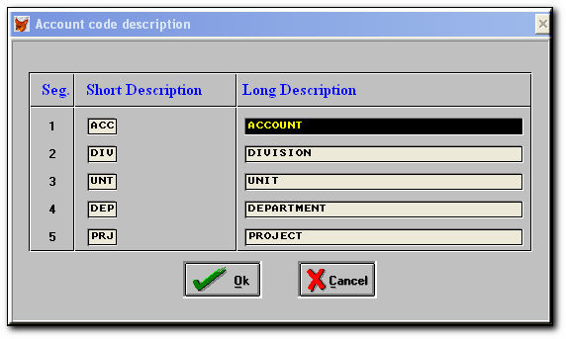

Screen 5: Replace existing values of segments
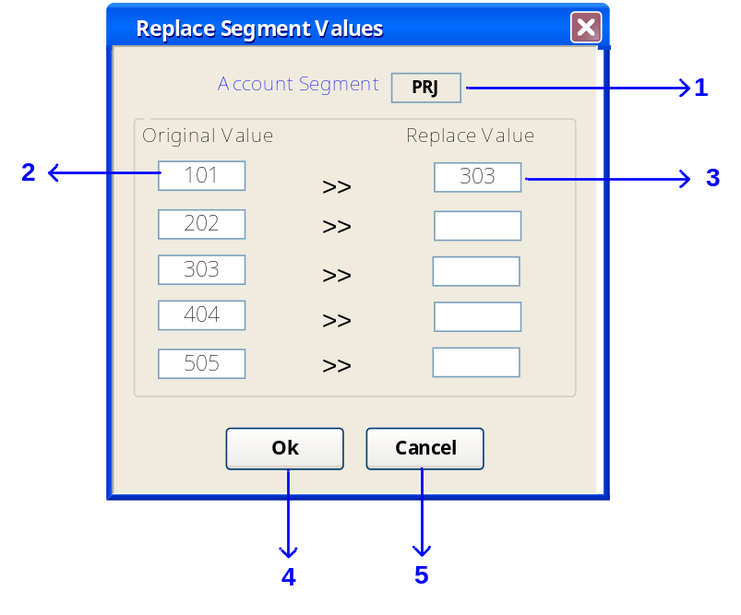

Ser. | Attribute | Value
1 | Description | The selected account segment from the main GL account code structure modifier screen.
 | Control Type | Edit boxes
 | Caption | Account Segment
 | Disabled | True
2 | Description | The list of original values existing for the selected segment.
 | Control Type | Edit boxes
 | Caption | Original Value
 | Disabled | True
3 | Description | Where the user will enter the replaced values.
 | Control Type | Edit boxes
 | Caption | Replace Values
 | Enabled | True
4 | Description | Ok command to save changed values
 | Control Type | Command button
 | Caption | OK
 | Enabled | True (if at least one of the replace value edit boxes contains a value) Else disable the Ok command since no changed values have been entered.
 | On Click | Save in GLVALCHG
5 | Description | Cancels any action taken by the user in this screen
 | Control Type | Command Button
 | Caption | ‘Cancel’
 | Enabled | True
 | On Click | Close screen and return to GL Code Structure Modifier

Screen 6: List of previous and new account codes
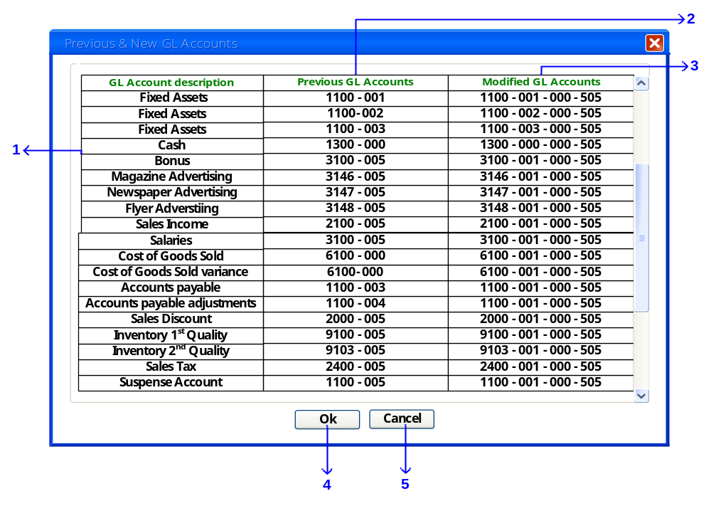 UI Rules
Ser. | Attribute | Value
1 | Description | Account description
 | Control Type | Grid Column
 | Caption | GL Account Description
 | Disabled | True
2 | Description | Previous GL Account (prior to modification)
 | Control Type | Grid Column
 | Caption | ‘Previous GL Account’
 | Disabled | True
3 | Description | Modified GL Account codes (the account codes after the structure modifications)
 | Control Type | Grid Column
 | Caption | Modified GL Account
 | Enabled | True
4 | Description | Ok command to save changed values
 | Control Type | Command button
 | Caption | OK
 | On Click | Save accounts changed manually in the accounts table.
5 | Description | Cancels any action taken by the user in this screen
 | Control Type | Command Button
 | Caption | ‘Cancel’
 | Enabled | True
 | On Click | Close screen and return to GL Code Structure Modifier

Database Design
This transaction will be stored in three new tables:

    - GL Structure Change table: in which will store if any change in the GL structure has taken place. i.e the total number of digits of the account code structure, the number of segments within the structure and the ,mask based on which Accod and all of the aria tables will be consequently updated.

    - GL Segment Change: in which we will store the detailed for each segment; it previous and new size (number of digits), description.

    - GL Value Change: in which we will store replaced values for each segment.. One or more previous and new value for each segment..
